The Independent Living Center of the North Shore and Cape Ann, Inc.

Through The All People Accessible Business project (APAB), ILCNSCA trained Volunteer Surveyors conduct accessibility surveys of local businesses. Volunteer Surveyors meet monthly to review survey results and network with other Volunteer Surveyors.

ILCNSCA promotes businesses that are accessible to enable the public to make informed choices regarding which businesses meet their needs.
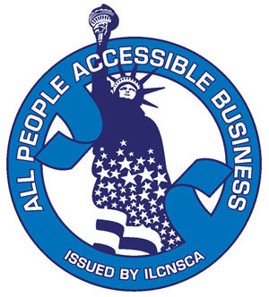

APAB Monthly Meeting
For current and potential APAB Volunteer Surveyors

Wednesday, September 13, 2017 from 3:00 PM – 4:00 PM
ILCNSCA Main Office: 27 Congress Street, Suite 107, Salem, MA 01970

RSVP with Shawn McDuff at:

Phone: 978-741-0077 ext.140
Email: smcduff@ilcnsca.org

For communications accommodations, please RSVP two weeks in advance. ILCNSCA maintains a scent free environment, so please refrain from wearing perfumes or scented products to accommodate persons with chemical sensitivities. Photographs and/or video may be taken for ILCNSCA publication. We will respect all requests to not be photographed, please inform us at time of RSVP or at arrival.

